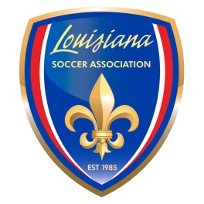

Safety Addendum to
Club Tournament Hosting Agreement

This Addendum is attached to and made a part of the US Youth Soccer Tournament or Games Hosting Agreement submitted by _______________________________________________________________
Name of Club
for the ______________________________________________________________________to be held
Name of Tournament
on ____________________________________ at ____________________________________________
Dates of Tournament Site of Tournament

In consideration of permission granted to host a tournament or games as set forth on the Hosting Agreement, the Club hereby certify as follows (check each circle that applies):

⃝ All adults who will be interacting with children during the Club’s tournament(s) are or will, before the tournament, be approved through the LSA Risk Management process.
⃝ The Club shall inspect the fields to be used during the tournament and shall insure that they are safe and playable at all times and shall paint lines on the spectator side of each field no less than six (6) feet from the sideline and behind which all spectators must be situated.
⃝ The Club shall inspect the goals to be used during the tournament and shall insure that they are safely anchored at all times.
⃝ The Club shall employ the services of a sufficient number of certified athletic trainer or trainers to insure the medical safety of the players.
⃝ The Club shall employ sufficient law enforcement officers to insure traffic safety while entering and leaving the tournament field facility.
⃝ The Club has a written Emergency Action Plan that addresses medical, environmental and security emergencies including, but not limited to
Lightning and Severe Weather Protocol
Field Conditions Protocol
Lost Child Protocol
Heat Index Protocol
and the Club shall observe all aspects of such Emergency Action Plan at all times.
⃝ The Club shall maintain reports and records of all Incidents including but not limited to injuries.
⃝ The Club shall observe the LSA Policy on the prohibition of the use of unmanned aircraft (drones) at all times.
⃝ The Club shall insure that all tournament volunteers and officials are aware of all of the Club’s Safety Protocols and Guidelines.

The Host Club also agrees to provide LSA with copies of any such required written tournament policies, procedures and protocols as well as its Emergency Action Plan immediately upon LSA’s request.

The Host Club understands and agrees that failure to comply with any of its Safety Guidelines may result in the withdrawal by LSA of approval to host any tournament.

______________________________________________________ __________________________
Club President, Executive Director or Tournament Director Date

Rev. 11/2017

